Project 1: Explore Weather Trends

Andy Soelistio
Wed, 12-Sep-2018

SQL Queries used to obtain Weather Data for a city – Singapore.
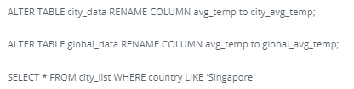

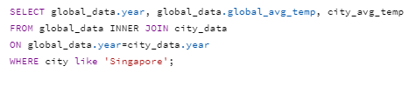

I download the query results into my local computer and rename the csv file to ‘Project1_WeatherTrends.csv’.

I use EXCEL to open the csv file. I create 2 new columns ‘global_7_MA_temp’ and city_7_MA_temp. These are where 7 Moving average average temperature will be placed.
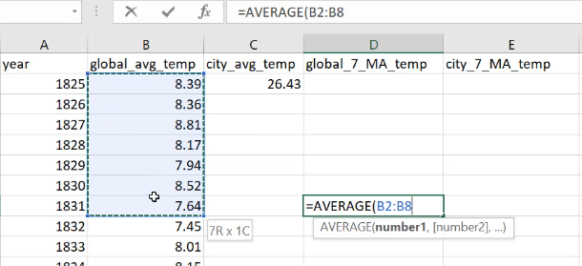
This is shown below:

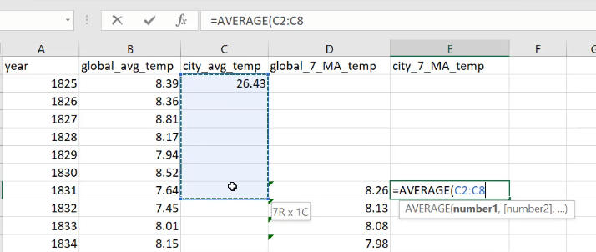
Now it’s time to tidy up data. Note below that from year 1825 to 1838 the data is either
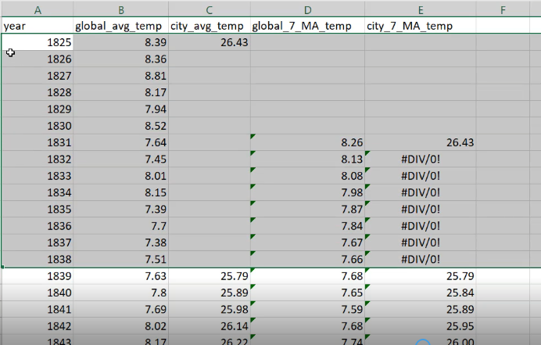
blank or not divisible by zero. I delete 14 rows out of 180s rows and this deletion will not prevent us from understanding the overall weather trends for the past 180 years. Therefore I delete these rows.

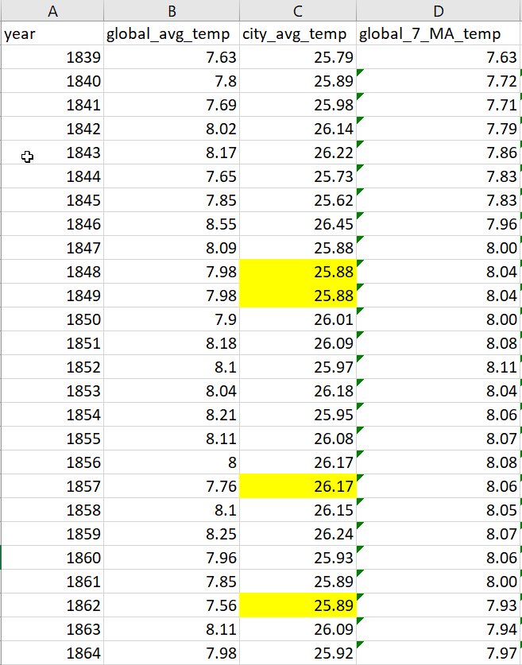
Also the column ‘city_avg_temp’ has some blank cells. I fill the blank cell with previous year’s value as shown in yellow highlight below.

Observations

After tidying up raw data in EXCEL, it’s time to plot line chart and make some observations. Note line blue is data for Singapore weather trend and line orange is data for Global weather trend.

Observation 1: The temperature for Singapore is approximately 20° Celcius hotter than the global temperature. This is not surprising since Singapore is located near the equator. Figure 1 however doesn’t tell us the weather trend of the past 180 years. We need to zoom in the chart.

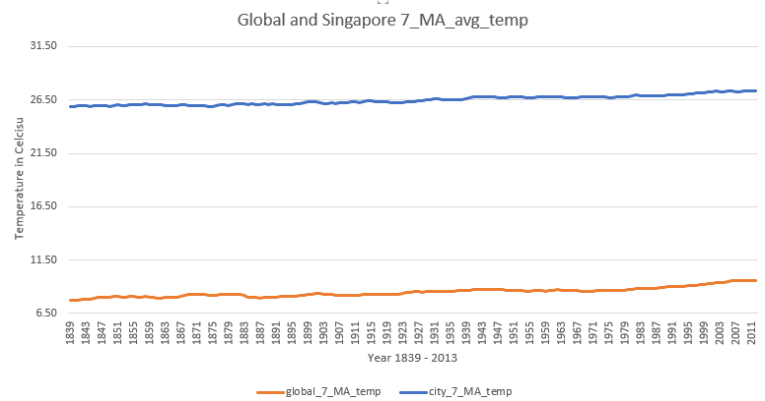
Figure 1

Observation 2: After zooming in our line chart, we can see the weather trend more clearly. This is shown in Figure 2 and Figure 3. From Figure 2 and 3, we can observe that both the global and Singapore temperature are on the rise for the past 180 years.
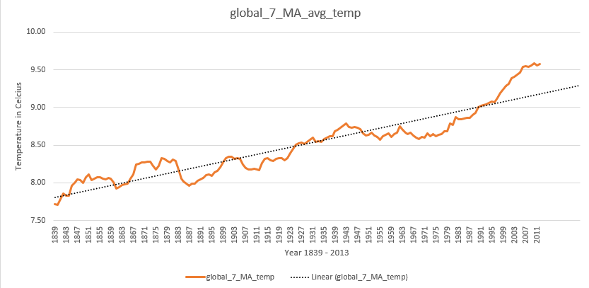
Figure 2: Global Average Temperature

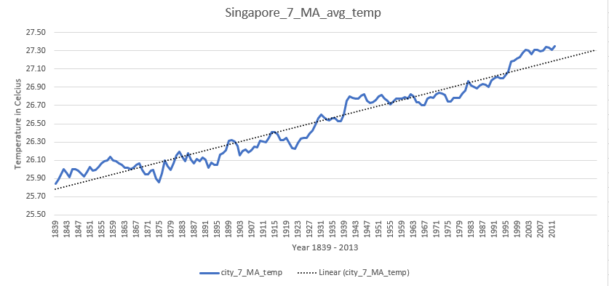
Figure 3: Singapore Average Temperature

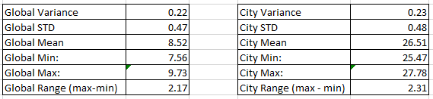
Figure 4: Statistics Data from column ‘global_avg_temp’ and ‘city_avg_temp’

Observation 3: Since 95% of data lies within 2 STD (standard deviation), we can say that during the past 180 years, Singapore’s temperature lies mostly (95% of the time) between 25.55 °C and 26.99 °C with an average temperature of 26.51 °C. Global’s temperature lies between 7.58 °C and 9.46 °C with an average temperature of 8.52 °C.

Observation 4: From Figure 2 and 3, we can also observe that the line chart goes up and below the trendline. It tends to regress towards the trendline. If we can get the equation for this trendline, we can predict the temperature in the future.

Observation 5: From Figure 4, the city’s max and min difference is 2.31 °C. If we divide this range by our sample size (year 2013 – year 1839, in my case since I deleted some rows) -- n = 174, then we get an annual temperature rise of approximately 2.31/174 = 0.013 °C.

Annual global temperature rise is 2.17/174 = 0.012 °C. If we extrapolate this trend to 50 years in the future, average global temperature will rise by 0.012 x 50 = 0.6 °C.

